# The App

**Main Screen:**

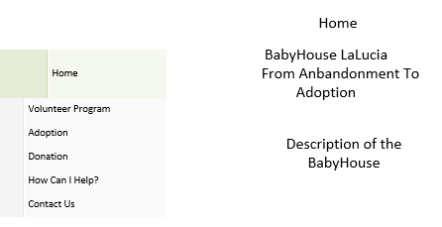

After logging in this screen will display the Home Screen. The home screen will give a brief description of the Baby House LaLucia. On the left hand side will be a menu that slides in from the left with the possible pages you can go too.

**Login Screen:**

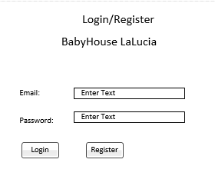

This is where the user can login or register using the mobile app. The user will be able to Login with Facebook or Google Plus account.

**Volunteer Screen:**

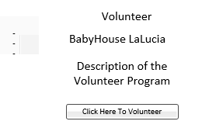

The user will be able to push a button sending a notification with all the users’ details saying they are available to work. Also gives a brief description of the volunteer program.

**Adoption Screen:**

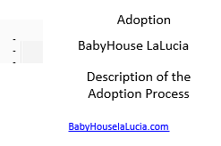

This screen will tell the user how to Adopt a baby step by step from Baby House LaLucia. Links will be provided to relative websites helping users better understand how to adopt.

**Donations:**

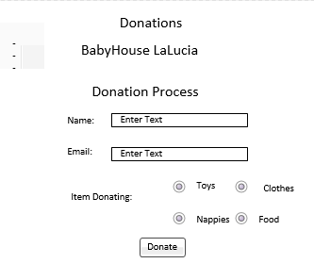

This screen will allow the user to donate to Baby House LaLucia by filling in the required information and clicking donate. After donating the Baby House LaLucia will send a thank you email to the user.

**Contact Us Screen:**

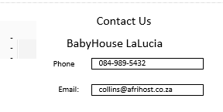

This screen will give the user all the contact details required to contact the Baby House LaLucia for further information.